MURA 2018 Annual Business Meeting
Reynolds Alumni Center
March 17, 2018

Call to Order and Welcome: The meeting was called to order at 10:00 a.m. by President Margie Sable.

Business Meeting
Campus Update: Chancellor Alexander Cartwright and Marty Oetting, Chancellor’s Chief of Staff
In his role as Chief of Staff, Marty has seen a lot of change over the institution during the recent past with many new faces such as among the Chancellor’s Staff, Deans’ Council and other tremendous leaders who are charting the course of the University with much energy and excitement. He discussed the enrollment situation and the proposed budget cuts from the Governor and legislature. He also answered MURA members’ questions.
The Chancellor arrived at the end of the meeting and after his remarks he answered questions from the floor. He stated that he is interested in looking at things that need emphasis with balance in mind in order to make things work out financially in the end. It is imperative that the University strategically place and individually examine all departments and programs. A program-level review made up of faculty members was conducted last fall. The review committee generated a set of recommendations of some areas that need to be discontinued. He stated that these are only recommendations not decisions. The Chancellor is asking deans, directors and department chairs to provide additional feedback by the end of the semester to be used in making decisions. Data may include numbers of students enrolled, student grades, research dollars generated, publications, books citations, etc. in addition to looking at programs department by department. The task at hand is to identify where among the University departments are the strong areas and/or things that are not so strong; there are a lot of factors to consider.
Pension Plan Update: Tom Richards, UM Treasurer and Chief Investment Officer (See http://mura-missouri.com/Events/Annual Business Meeting March 17 for detailed documents.) There will not be a cut to MU Retirees’ benefits checks as the pension plan is protected by Missouri law. This pension plan is one of the best publicly funded plans in the US---82% funding level. The message to take away is that the benefit stream is safe and sound.
Approval of 2017 Minutes: Secretary Leslie Palmer
It was moved by Doris Littrell and seconded by Dick Otto that the minutes from the 2017 MURA annual business meeting be approved. Passed.
Membership Report: Chair Dick Otto
The total number of MURA members in good standing as of this date is 862. This is approximately five percent growth in membership from 822 in March 2017. We have 774 life members compared to 727 last year which is up approximately 6.5% over last year. MURA has 76 annual (one year) members in good standing paid for 2018 and 12 beyond 2018 with some through 2020. Last year at this time there were 86 members who had not paid from the previous years. This year

Membership Report (continued):
that is down to 52 total members. Total members in good standing is 862 – 774 Life Members and 88 ANNUAL (76 plus 12) members. LIFE members make up 89.8% at the current time versus 88.4% a year ago. Dick welcomes the assistance of anyone who would like to volunteer in efforts to “work” this group for renewals with personal contacts and e-mails. Everyone here is a member of the membership committee. Everyone is responsible to help out with the recruitment of new members. If there is any chance that someone has or will be getting a new email address, please be sure to contact us with the new email address.
Nominating Committee Report & VOTE on Officers: Past-Presidents Marty Townsend and Tom Henderson
Marty Townsend (Past President) dispensed with the reading of the nominees’ brief biographies as they were presented in the February, 2018, MURA newsletter. Many thanks were offered to the members of the MURA nominating committee (Tom Henderson, Jim Koller, Linda Cook and Larry Windmoeller) for coming up with what is being presented as a very fine slate of individuals for MURA Board membership beginning July 1, 2018:
PRESIDENT ELECT AND PROGRAM CHAIR – Betsy Garrett (2018-2019)
TREASURER – Rob Weagley, first, two-year term (2018-2020)
STAFF MEMBER AT LARGE – Nancy Johnson, first, three-year term (2018-2021)
FACULTY MEMBER AT LARGE – Bill Fisch, first, three-year term (2018-2021)
It was moved and seconded that the slate be approved by acclamation as presented. Passed. Special thanks to the candidates themselves for their participation and willingness to serve.
Treasurer’s Report: Rob Weagley for Debbie Robison (see reports below for Cash Flow ended March 8, 2018)
MURA’s cash receipts exceeded cash disbursements for the first 8+ months of the fiscal year by $3,131.
Highlights from the financial statements:
- Dues are about $1,765 ahead of last year at this time. $1,583 of this increase is in lifetime memberships.
- It is assumed that the fall and spring newsletter costs will be reimbursed by the MU campus and UM System. The cost last year was $1,590.
- The monthly breakfast events are now largely being collected online through the Alumni Spaces portal. The cost to MURA is a 5% transaction fee. This 5% fee covers both the cost to use the Alumni Spaces portal and the credit card transaction fee.
- The Board authorized a contribution of the Association funds to the MURA Scholarship Endowment Fund up to $10,000. This is a matching contribution based on member donations. As of this date, $2,265 has been transferred.
Overall, the Association is currently in good financial condition. A concern looking forward is the ability of the Association to cover its cost of operations in the future due to the large number of lifetime members. With a reduced amount of income will the Investment account be sufficient to cover these costs? An increase in our lifetime membership dues would allow us to not only ensure sufficient funds to cover those future costs but also allow us to expand our services to our members if considered appropriate.
Although the MURA Scholarship Endowment Fund is NOT an asset of our organization, but instead of MU, the board did ask that I update you on its status. Our endowment balance as of March 2, 2018 was $43,222.
Communications Committee Report: Barb Harris
Barb Harris introduced the new members of the Communications Committee: Nancy Johnson set up and is maintaining the MURA Facebook page; Maggie Walter and Pat Smith (Journalism School retirees!) are handling the newsletter production; and Judy Maseles maintains the MURA website. Barb asked for reaction from the members if the Board decided to go all electronic on the newsletter for everyone who we do have an address for; members had no negative feedback. Barb reported that we have about 180 members who do not have an electronic address on file with MURA. Barb has deleted over 100 ‘past due’ members from the membership list so if any friends or neighbors comment about not getting e-news anymore, ask them if they are paid up! If anyone was deleted in error to please let Barb know.
Awards Committee Report: Chair Larry Windmoeller
The 2018 Chancellor's Faculty Retiree of the Year recipient is Dr. Robert J. Churchill. The 2018 Chancellor's Staff Retiree of the Year recipient is Richard J. Otto. The nomination dossiers for individuals not selected will be kept in an active file by the Awards Committee for two years. Additional information added to the file should be submitted as an update.
Program Committee Report: Chair Jo Turner
MURA’s Spring Social will be hosted on Monday, April 16, from 3:00-5:00, by UM System President Mun Choi and Mrs. Choi at Providence Point. Pre-registration is required along with a suggested minimum donation of $25 per person to the MURA Kitty Dickerson Scholarship Fund. Donations will be matched by a special MURA allocation. Invitations will be sent via email to MURA members with valid email addresses, with paper invitations going to the rest.
MURA’s Ray Schroeder Picnic is Wednesday, May 9, 10:30, at Twin Lakes Recreation Area.
The Chancellor’s Retiree event is May 18. Invitations will be sent by the Chancellor’s office. The program will include a resource fair and recognition of this year’s faculty and staff retiree awards.
Turner invited interested MURA members to join the committee. The next meeting is April 11, 9:30-11:00 a.m. Contact her at turnerlj@missouri.edu if interested.
Kitty Dickerson MURA Scholarship Committee Report: Ken Hutchinson for Co-chairs Kee Groshong and Gary Smith
Donations to date total $45,431.37. We have awarded three scholarships at $500 each. President Mun Choi and his wife, Suzanne, are again hosting the MURA Spring Social as a fundraising event for the Kitty Dickerson MURA Scholarship. This donation is tax deductible and a special MURA allocation will match each donation. This year’s scholarship recipients will be invited to the Chancellor’s Retiree event on May 18.
Education Committee Report: Dick and Anne Hessler, Co-chairs
The April 3 Breakfast presenter is Dr. Judith Miles, M.D., Ph.D., a University of Missouri-Columbia Professor Emerita in Child Health-Genetics, speaking on “Catatonic Regression in Down Syndrome.” The breakfast speaker on May 1 is Chancellor Alexander Cartwright. The June 5 speaker will be Peter Hessler who will likely provide information regarding his recent Egypt trip. Mary Anne McCollum will coordinate a legislative candidate forum on September 11. The Honorable Patricia Breckenridge, Missouri Supreme Court, will speak on October 2. The committee will finalize the 2018 MURA Breakfast slate of speakers soon. The committee welcomes ideas and recommendations for speakers from all MURA members.

President’s Report: President Margie Sable (See reports below)
Old Business:
New Business:
Proposed Bylaws Changes By-Laws Change – The following amendment to the MURA By-Laws is proposed:

- Scholarship Committee

- Section 8. Standing Committees. Add MURA Scholarship at the end of sentence 1.
- Add Section 8, item m. The MURA Scholarship Committee shall oversee the Kitty Dickerson MURA Scholarship Fund and carry out strategies to secure donations to the fund. The committee shall coordinate with MU on the annual selection, announcement and recognition of scholarship recipients. The committee shall also identify additional opportunities for new and/or expanded MURA scholarships.

- Dues Change – The following change in the MURA dues structure is proposed: Annual MURA membership dues will increase to $12.50 per year and lifetime membership will increase to $100, effective January 1, 2019.

Marty Townsend motioned that the proposed bylaws changes be approved; Maggie Walter, seconded. Motion passed.
Flagship Council Report: Tom Henderson, Past President
The University of Missouri Flagship Council (MFC) was formed in 2005 to help support the University as well as to maintain and enhance its traditional role as Missouri’s premier public teaching, research and service university. The Flagship Council is a private organization of alumni and friends working together to build and protect the University of Missouri as a flagship university (one of 34 public members of the elite Association of American Universities). The Flagship Council is represented by a lobbyist who works with legislators on a daily basis, testifies in front of committees, and communicates about the work of the flagship university. The following are strategies currently in place in the effort to build and strengthen the University of Missouri as a flagship university:
- Build Face to Face Relationships with Elected Officials and Particularly with Members of the General Assembly and Statewide Office Holders.

Examples include but are not limited to Legislative Breakfasts in the Capitol. Two more upcoming breakfasts scheduled for April 4 and May 1, with the session ending May 18.
- Partner with other organizations that are committed to a better understanding of what Mizzou is and does on a daily basis.

Examples include an upcoming luncheon meeting in Jefferson City on April 23 that is co-sponsored by the Columbia Area Chamber of Commerce. Further, MFC is planning the September MURA breakfast meeting to host a candidate’s forum for those seeking legislative seats in the 2018 November election.
- Members receive a weekly email communication that highlights the activities and good news going on at Mizzou and an update of what is going on during the legislative session with respect to higher education.

Flagship Council Report (continued):
- That legislative update comes from the MFC lobbyist, Mr. Tom Rackers, who is hired by the MFC associated Political Action Committee (PAC), a 506C, to keep members informed of what is happening with legislation, provide information from a private support organization and testify as needed on bills that MFC supports.

Mary Anne McCollum distributed a MFC brochure and membership envelope.
The meeting was adjourned at 12:30 p.m.

Respectfully,

Leslie J. Palmer
MURA Board Secretary

Minutes to be approved at the Annual Business Meeting Spring 2018

ADDENDUM:
Statement of Cash Flows
President’s Report
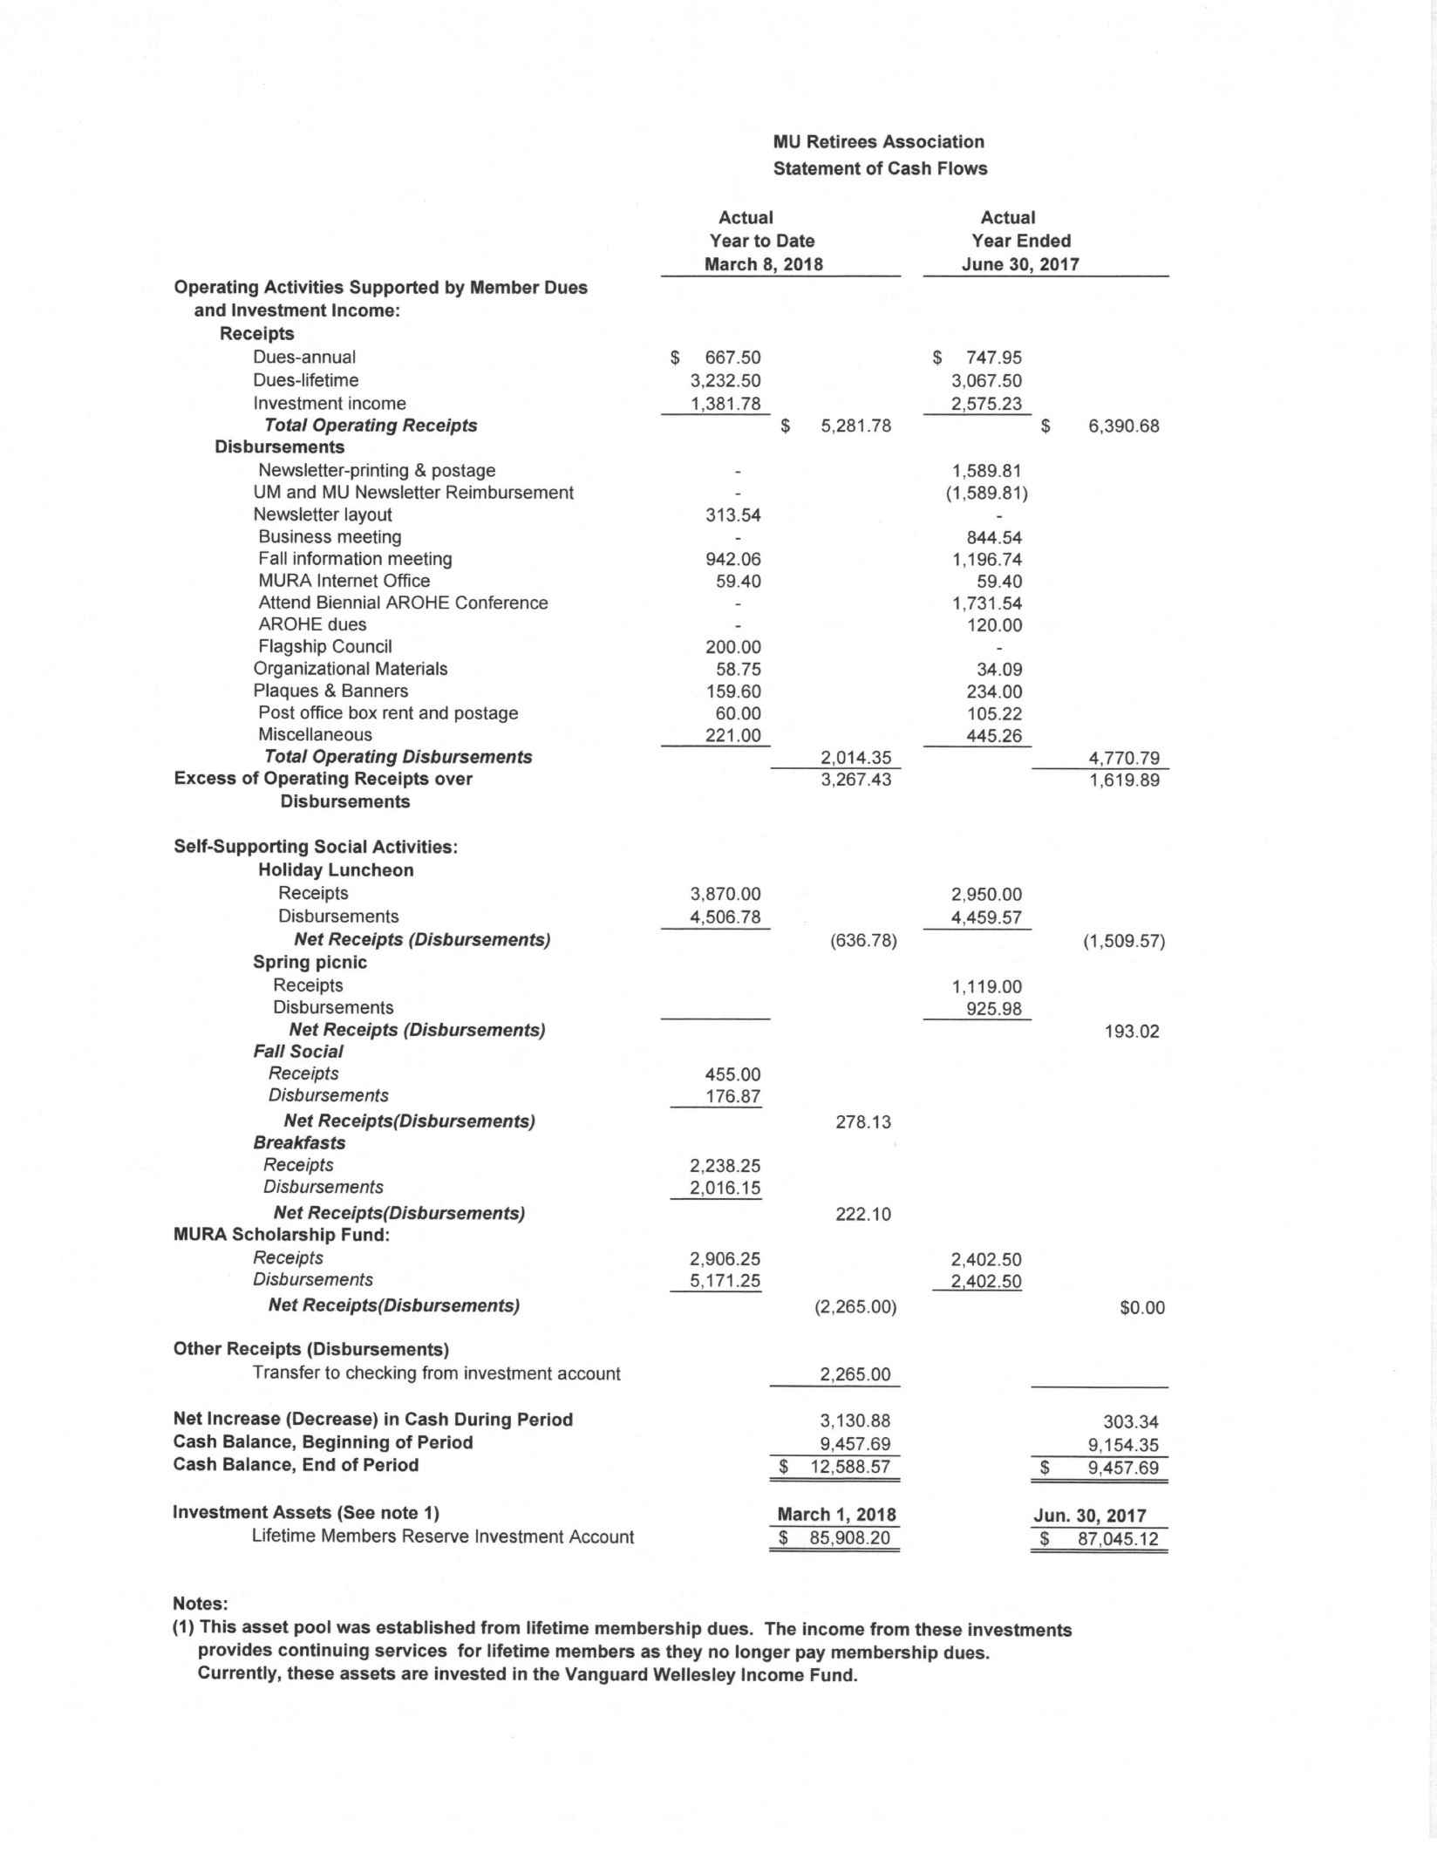

March 17, 2018

To: MURA Members
From: Margie Sable, MURA President
RE: Annual President’s Report
This year saw the appointment of Alexander Cartwright as the new Chancellor. The MURA leadership had an opportunity to meet with him in the Fall and will do so again this spring. He will also be speaking at our May breakfast and we look forward to working with him in the coming years. The four-campus system retiree organization leadership (MU, UMKC, UMSL and MS&T) also meet twice a year with President Choi. Heartfelt thanks to Linda Cook, who serves as our liaison to the Chancellor’s and President’s office and arranges these meetings.
One of our great frustrations is not having information on new retirees. We learned this year that the UM System can send out one email per year on our behalf, and we will soon be sending out an email to all MU and UM System retirees with information about MURA and an invitation to join. I hope that this will increase our membership. We also encourage you to let your retiring friends and colleagues know about MURA and direct them to the membership application on our website.
Among this year’s accomplishments has been the initiation of an online registration system, It was first proposed last year by past-president Marty Townsend and I am delighted that it has come to fruition. Alumni Spaces was started by MU alum and it is used by alumni associations nationally. We began using it in January, and although we are still working out the kinks, we are very glad to be able to register our members for our events through an electronic portal.
Another great accomplishment has been the addition of a fantastic media/communications team. Judy Maseles is our new web mistress and has done a wonderful job of re-vamping our website. I am sure that you all agree that it is much easier to navigate now. Nancy Johnson created and manages our Facebook page. And this fall we recruited Pat Smith and Maggie Walter as designer and editor of our newsletter. They produced our February, 2018 newsletter and did a fantastic job. Thanks so much to this team for your great work!
The MURA Kitty Dickerson Scholarship is fully endowed and continues to grow through your donations and your volunteering at the MU bookstore. We are so grateful to President Choi for hosting the spring social again, and for allowing us to use this event again as a fund-raiser for the scholarship. Thanks to co-chairs Gary Smith and Kee Groshong and to Nancy Schultz.
I have enjoyed my year as president tremendously. I have many new friends and have enjoyed continuing the friendships I started while working at Mizzou. I’m especially grateful to the MURA board and committee members and thank them for all of the work that they do to keep this organization running so smoothly: Marty Townsend, Jo Turner, Leslie Palmer, Deb Robison, Barb Harris, Dick Otto, Dick & Anne Hessler and the other board members and past presidents. Thank you!

